MAE ANGELICA S. FORTU

BSIT – BLOCK 1

DEGREE OF FREEDOM FORMULA

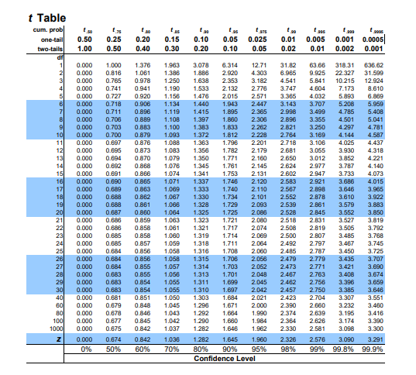T TEST FOR INDEPENDENT SAMPLES: CHI SQUARES

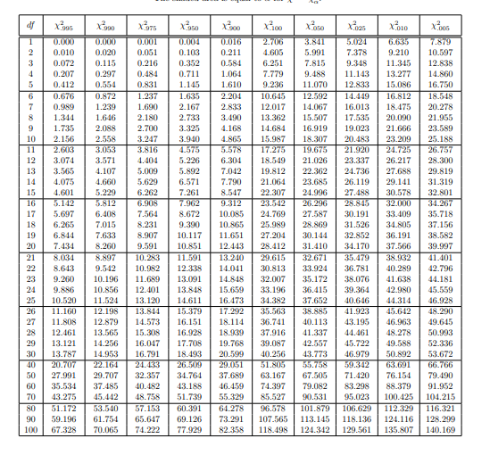

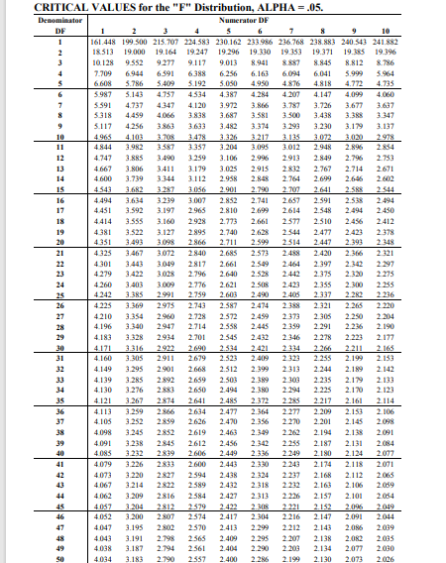ANOVA OR F TEST PEARSON’S CORRELATION TABLE

